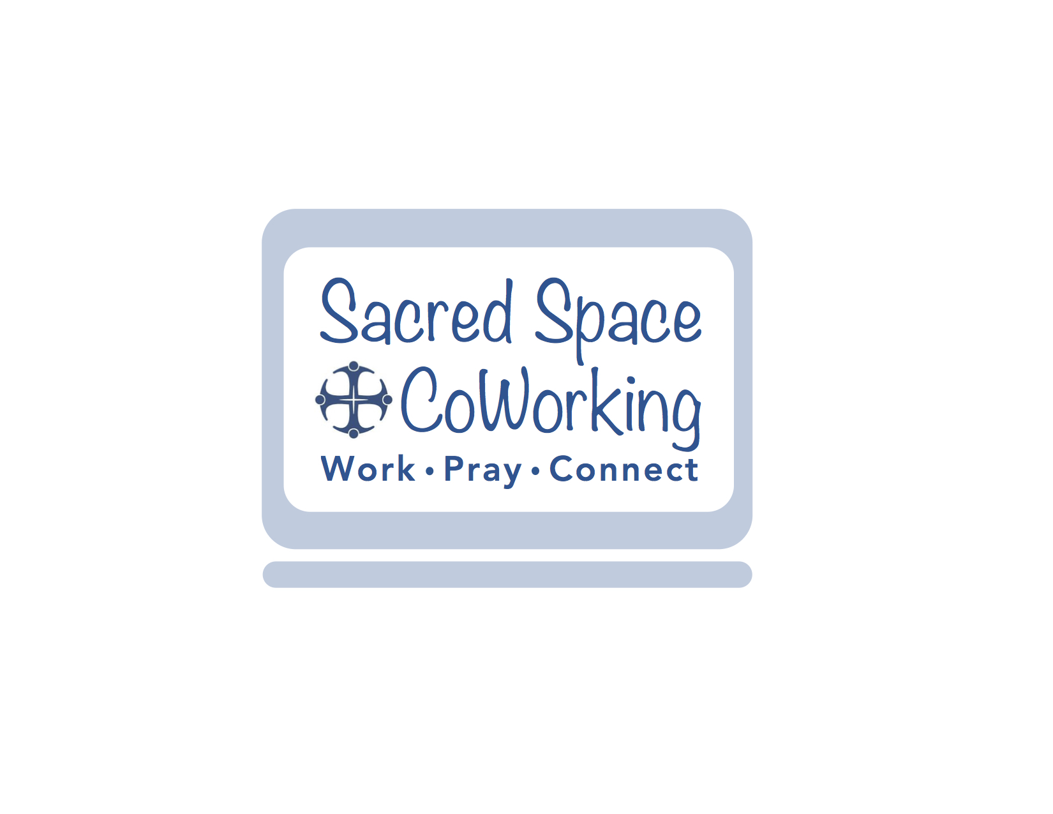

Sacred Space Co-Working is an ecumenical sacred co-working community for those who need a professional work setting free of distractions. We offer a creative workspace that merges spirituality with productivity.

Who We Are
Our community strives to nurture the integration of God into our everyday lives while bringing together a group of people who can motivate and inspire each other to advance each individual business.
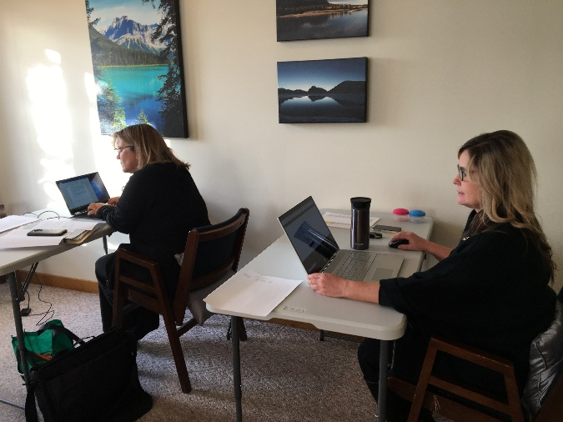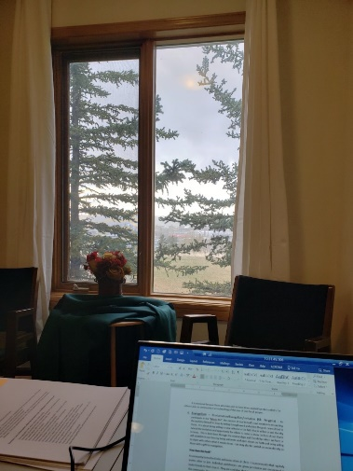
If you are feeling isolated being at home, working in a shared space once per week can give you structure and routine in a positive energy environment of like-minded people while deepening your relationship with God.
Sacred Space Co-Working upholds both work and worship as equally sacred. Each morning begins with prayers of blessing and intention after which the community blesses the workspace and begins work. Around noon, we break for a 15-minute meditation/ prayer time together. The workday ends with a brief closing prayer.

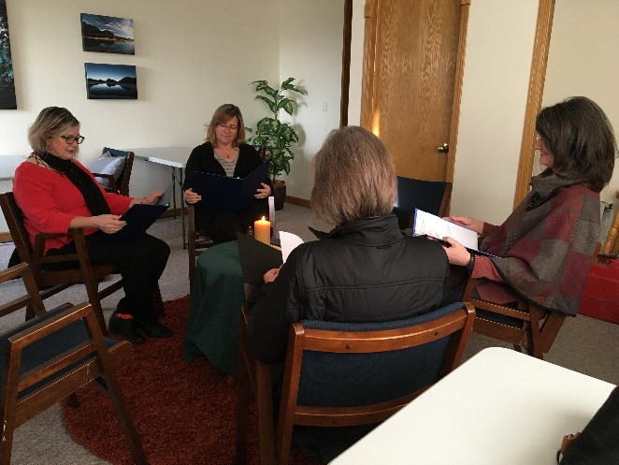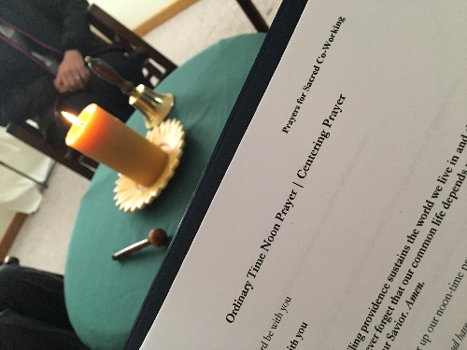

Can you see yourself doing your independent work here at Sacred Space Co-Working? Are you interested in achieving a better work/spirit/life balance with others who also hold these values? If so, please contact us with any questions or to schedule a tour at 403-660-5636 or e: allsaintsretreatcentre@outlook.com.

Pricing

Shared working space starting January 1, 2020: $30/day or $100/month
Boardroom: $25/hour or $50/half day or $80/day.
We accept cash, e-transfer, or credit cards.

Your fee includes a quiet workspace, an opportunity to integrate work & prayer in an atmospheric community, wifi, printing/scanning/copying services, the living room, the kitchen area with free coffee, tea, and water, 3 washrooms, an office for private phone calls, & two outside areas.

What is expected of you?
Full participation in prayer & quiet work, fees paid on time, a respectful participation in the co-working community.

Hours of Operation

We are currently open from 8:45am to 4:00pm on Thursdays.

